STUDENT WORKBOOK 7: SOFTWARE DESIGN & IMPLEMENTATION

Course: Software Engineering / IT Project
Topic: Architectural Design
Group: GROUP 2
Project: HEALTHBRIDGE
Institution: Mbarara University of Science and Technology

SECTION A: UNDERSTANDING SOFTWARE ARCHITECTURE

Activity A1: Define Software Architecture in Your Own Words
Software architecture is the high-level structure of a software system — it defines the principal components of the system, how those components interact with one another, and the governing design principles that guide the system's development and evolution. It acts as the blueprint that determines how the system is organised and how its parts work together to fulfil the system's goals. For HealthBridge, the architecture defines how the user interface, business logic, database, and notification service are structured and connected so that patients can find clinics and health services quickly and reliably.

Activity A2: Main Components of HealthBridge
- User Management, handles authentication of patients and administrators, issues JWT tokens to all other components.
- Course/Clinic Content Module, stores and serves clinic information, service types, locations, and operating hours.
- Search & Filter Engine, processes location-based and service-type queries from users, queries the database, and returns results.
- Notification Service, listens for system events (e.g., data updates, appointment alerts) and pushes notifications to relevant users.
- Database Layer, PostgreSQL/MySQL relational database stores all clinic data, user credentials, and system logs; Redis cache speeds up frequent queries.

Activity A3: Simple Architecture Diagram (Block Description)
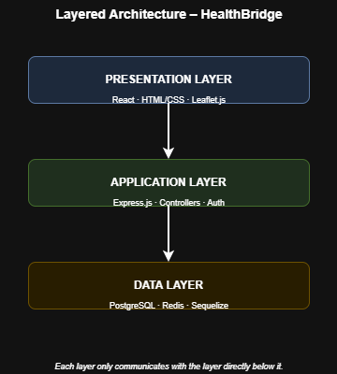
All layers communicate over HTTPS; the Controller mediates between the View and the Model (database).

SECTION B: ARCHITECTURAL DESIGN DECISIONS

Activity B1: Non-Functional Requirements for HealthBridge
- Performance, Search results must be returned in under 2 seconds even during peak usage.
- Security, All user data and health-related searches must be protected through encryption, authentication, and input validation.
- Availability, The system must be accessible at all times (target 99% uptime) with automatic recovery from failure.

Activity B2: Linking Requirements to Architecture
1. Performance:
Requirement: Search results delivered in under 2 seconds.
Explanation: Redis caching stores results of frequently searched clinic queries so the database is not hit repeatedly. SQL indexes on location and service-type fields speed up queries. A CDN (Content Delivery Network) serves static assets (images, CSS) faster to the browser.
2. Security:
Requirement: User data and health searches must be protected.
Explanation: All traffic is encrypted using HTTPS/TLS. Passwords are hashed using bcrypt with salt. JWT tokens control session authentication. Parameterised SQL queries prevent SQL injection. Sensitive search terms (e.g., HIV clinic searches) are never written to server logs, upholding GDPR/HIPAA principles.
3. Availability:
Requirement: 99% uptime with recovery capability.
Explanation: HealthBridge is deployed on a cloud platform (e.g., Google Cloud) with auto-restart policies. Daily database backups ensure data recovery. An admin panel allows non-technical staff to update clinic data without developer involvement, reducing downtime caused by data errors.

SECTION C: ARCHITECTURAL VIEWS (4+1 MODEL)

Activity C1: Logical View; Key Modules in HealthBridge
The logical view describes what the system does and how its modules are organised functionally.
Key modules: User Management Module, Clinic Search Module, Clinic Data/Content Module, Notification Module, Admin CRUD Module, and the Database Access Layer (ORM — Sequelize). Each module has a clearly defined responsibility and communicates with others through defined interfaces.

Activity C2: Process View; How Users Interact with the System
A user opens the HealthBridge web application in their browser. They enter a search term (for example "nearest HIV clinic in Mbarara"). The React frontend sends an HTTP GET request to the Node.js/Express controller. The controller checks the Redis cache first; if the result exists, it is returned immediately. If not, the controller queries the PostgreSQL database using an optimised SQL query, caches the result in Redis, and returns clinic details to the frontend. The user sees results rendered on an interactive map in under 2 seconds.

Activity C3: Development View; How the Team Divides the System
The codebase follows the MVC (Model-View-Controller) folder structure:
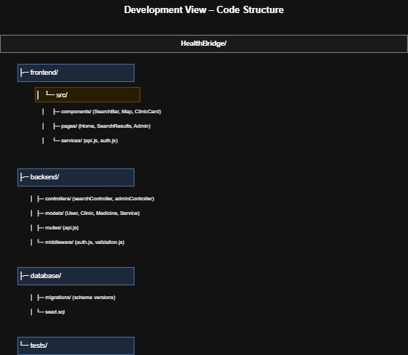
Team members are assigned to specific layers (frontend, backend, database) to work in parallel without conflict.

Activity C4: Physical View — Where the System Runs
HealthBridge is hosted on Google Cloud Platform (GCP):
• Web Server: Cloud Run container running Node.js/Express (auto-scales)
• Frontend: Static React build served via Firebase Hosting or CDN
• Database: Cloud SQL instance running PostgreSQL
• Cache: Redis instance on Cloud Memorystore
• Storage: Google Cloud Storage for media/static files
• Domain: HTTPS enforced via SSL certificate
Users access the system from any device with a browser — no installation required.

Activity C5: Use Case Scenario (+1 View)
Use Case: Patient Searches for a Nearby Clinic
Actor: Anonymous user (patient)
Precondition: User has internet access and opens HealthBridge in a browser.
Flow:
1. User enters search term and location.
2. System validates input and queries the database.
3. System returns a list of matching clinics with addresses, hours, and services.
4. User selects a clinic to view full details.
Postcondition: User has the clinic's contact information and can plan a visit.
This scenario validates the Logical, Process, and Physical views simultaneously.

SECTION D: ARCHITECTURAL PATTERNS

Activity D1: Pattern Selection
Selected Pattern: MVC (Model-View-Controller)

Activity D2: Justification
MVC is suitable for HealthBridge because it is a data-driven web application where separating the presentation layer from the business logic and the database is essential. Three reasons justify this choice:
1. Team collaboration: Different members can work on the Model (database), View (frontend), and Controller (backend API) simultaneously without merge conflicts.
2. Maintainability: Changing the UI does not require modifying the database schema, and vice versa.
3. Scalability: Each layer can be scaled independently — the frontend can be served via CDN while the backend scales horizontally on cloud infrastructure.

Activity D3: Pattern Application to HealthBridge
MODEL → PostgreSQL/MySQL schemas managed via Sequelize ORM
(Stores: Clinics, Users, Services, Locations, Logs)
VIEW → React.js / HTML+CSS pages rendered in the user's browser
(Pages: Search, Clinic Detail, Admin Dashboard)
CONTROLLER → Node.js / Express route handlers
(Routes: GET /clinics, POST /admin/clinic, PUT /admin/clinic/:id)
Flow: User action (View) → HTTP request → Controller → Model query → Response → View update

SECTION E: APPLICATION ARCHITECTURE

Activity E1: System Type
HealthBridge is a Web-based Information System with characteristics of both a Transaction Processing System (user searches are processed as transactions) and a Data Processing System (clinic data is continuously updated by administrators).

Activity E2: Key System Transactions/Operations
- User submits a clinic search query (location + service type) — system processes, queries DB, returns results.
- Administrator adds or updates clinic records via the CRUD admin panel.
- System authenticates a user login — validates credentials, issues JWT token.
- Notification service fires when new clinic data is added — alerts relevant stakeholders.
- Redis cache is refreshed when clinic data changes — ensures users always see current information.

SECTION F: WEB-BASED ARCHITECTURE (3-TIER)

Activity F1: 3-Tier Architecture for HealthBridge
TIER 1 — Presentation Layer (Frontend)
• Technology: React.js
• Responsibility: Renders the user interface in the browser; handles search input, maps, and clinic listings.
• Communication: Sends HTTP/HTTPS requests to the Application Layer via REST API.
TIER 2 — Application Layer (Backend)
• Technology: Node.js with Express.js
• Responsibility: Processes business logic — validates input, queries cache/database, applies security rules, and formats responses.
• Communication: Receives requests from Tier 1; queries Tier 3 for data.
TIER 3 — Data Layer (Database)
• Technology: PostgreSQL (primary DB) + Redis (cache)
• Responsibility: Stores all persistent data — clinic records, user accounts, service types. Redis holds cached search results for fast retrieval.
• Communication: Queried by the Application Layer only (no direct frontend access).

SECTION G: GROUP PROJECT TASKS

Task 1: Architecture Design Document — HealthBridge Summary
System Overview:
HealthBridge is a web-based health information system that helps patients in underserved communities locate nearby clinics, pharmacies, and health services by service type and location.
Architecture Diagram: MVC-based 3-tier web architecture deployed on Google Cloud.
Selected Pattern: MVC (Model-View-Controller)
Justification: Enables parallel team development, clean separation of concerns, and independent scaling of frontend and backend components.

Task 2: Diagrams Required
1. Block Diagram: Shows 5 main components (User Management, Search Engine, Clinic Content, Notification Service, Database) and their directional interactions.
2. Layered Diagram: Shows Presentation (React) → Application (Node/Express) → Data (PostgreSQL/Redis) layers.
3. Deployment Diagram: Shows Cloud Run (Node.js), Firebase Hosting (React), Cloud SQL (PostgreSQL), Cloud Memorystore (Redis) all connected over HTTPS.

Task 3: Scenarios
Scenario 1 Clinic Search: A patient visits HealthBridge, enters "maternal health clinic Kampala", and receives a list of clinics with addresses, phone numbers, and operating hours within 2 seconds.
Scenario 2 Admin Data Update: An NGO administrator logs into the admin panel, adds a new
clinic record with service types and GPS coordinates; the system validates the entry, saves to
PostgreSQL, clears the Redis cache, and the new clinic immediately appears in user searches.

SECTION H: REFLECTION

i. Why is architecture important before coding?
Architecture is important before coding because it establishes the structural blueprint of the entire system. Without it, developers would build components independently with no agreed interfaces, leading to integration failures, duplicated work, and poor performance. Architecture decisions such as choosing MVC or a cloud deployment model affect every aspect of the system from security to scalability. Changing architecture after coding begins is extremely costly; it is far cheaper to correct a design diagram than rewrite thousands of lines of code.

ii. Which architectural pattern did you choose and why?
We chose MVC (Model-View-Controller) because HealthBridge is a data-driven web application where the database schema, business logic, and user interface must evolve independently. MVC allows our team to divide labour cleanly frontend developers work on React Views while backend developers build Express Controllers and database Models simultaneously. It also aligns naturally with REST API design, which is the industry standard for web applications.

iii. How does your system ensure security and performance?
Security: HTTPS/TLS encrypts all data in transit. Passwords are hashed with bcrypt+salt. JWT tokens expire and are validated server-side. Parameterised SQL queries prevent SQL injection. Sensitive health searches are never stored in logs, protecting user privacy in line with GDPR/HIPAA principles.
Performance: Redis caches frequent clinic search results, reducing database load. SQL indexes on location and service type columns accelerate queries. A CDN serves static assets globally. Auto-scaling on Google Cloud handles peak traffic. Target: all search results returned in under 2 seconds.

iv. What challenges did you face?
1. Data accuracy: Clinic information in Uganda is often outdated or unavailable digitally; we needed to design an easy admin panel so non-technical NGO staff can keep data current without developer help.
2. Connectivity: Many target users have limited internet access, so we optimised page load sizes and implemented Redis caching aggressively to reduce repeated data transfer.
3. Privacy sensitivity: Health searches are highly sensitive; designing the system to avoid logging specific search terms required careful backend configuration.
4. Team coordination: Dividing work across 6 members required clear layer ownership and a shared Git branching strategy to avoid code conflicts.

SECTION I: DESIGN & IMPLEMENTATION WORKFLOW

Activity I1: System Context Diagram
External Actors and Systems connected to HealthBridge:
• Patient (anonymous user), searches for clinics and health services
• NGO Administrator, manages clinic records via admin panel
• Google Maps API, provides location/mapping services
• Email/SMS Gateway, sends notifications to users
• Cloud Infrastructure (Google Cloud) , hosts all system components
HealthBridge sits at the centre, receiving requests from patients and administrators, calling external APIs (Maps), and communicating with the cloud database.

Activity I2: Use Case Development
Use Case 1:
Name: Search for Health Facility
Actors: Patient (anonymous)
Description: A user enters a service type and location. The system queries the database, returns a ranked list of matching clinics with contact details and operating hours. The user can filter results by distance, service, or rating.
Use Case 2:
Name: Administrator Updates Clinic Record
Actors: NGO Administrator
Description: An authenticated administrator logs in using email and password. The system verifies credentials and issues a JWT token. The admin navigates to the clinic management panel, edits a clinic's hours or adds a new service, and saves. The system validates the input, updates the database, and clears the Redis cache.

Activity I3: Key System Objects
- User (Patient) — represents an anonymous or registered system user
- Clinic — represents a health facility with attributes: name, location, services, hours
- Service — represents a health service type (e.g., ANC, HIV testing, pharmacy)
- Admin — authenticated staff member with CRUD privileges
- SearchQuery — encapsulates a user's search parameters (location, service type, radius)

Activity I4: Object Responsibilities
Object Name: Clinic
Responsibilities:
• Store and manage all clinic-related data
• Be searchable by location and service type
• Be updatable by authenticated administrators only
Methods:
• findByLocation(lat, lng, radius): returns clinics within given radius
• findByService(serviceType): filters by health service offered
• create(data): adds a new clinic record
• update(id, data): modifies existing clinic details
• delete(id): removes a clinic from the system

SECTION J: UML DESIGN MODELS

Activity J1: Class Diagram — Key Classes
Class: User
Attributes: userId, name, email, passwordHash, role (patient|admin)
Methods: login(), logout(), resetPassword()
Class: Clinic
Attributes: clinicId, name, address, latitude, longitude, phone, operatingHours
Methods: findByLocation(), findByService(), update(), delete()
Class: Service
Attributes: serviceId, serviceName, description
Methods: getAll(), addToClinic(clinicId)
Class: SearchQuery
Attributes: queryId, userId, serviceType, location, radius, timestamp
Methods: execute(), getResults()
Relationships:
• Clinic has many Services (one-to-many)
• Admin manages Clinic (association)
• Patient creates SearchQuery (association)

Activity J2: Sequence Diagram — Clinic Search
Scenario: Patient searches for a clinic
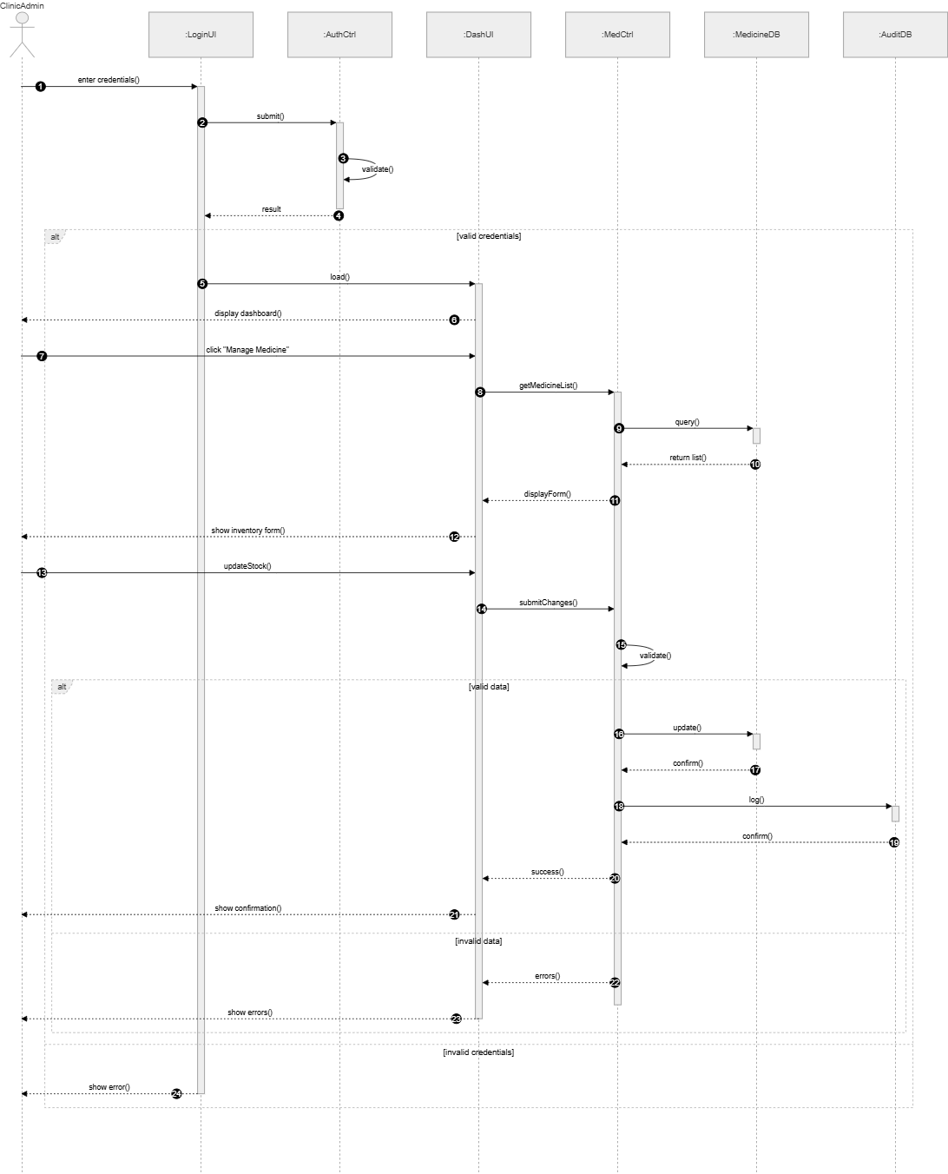

Activity J3: State Diagram — Clinic Record (Optional)
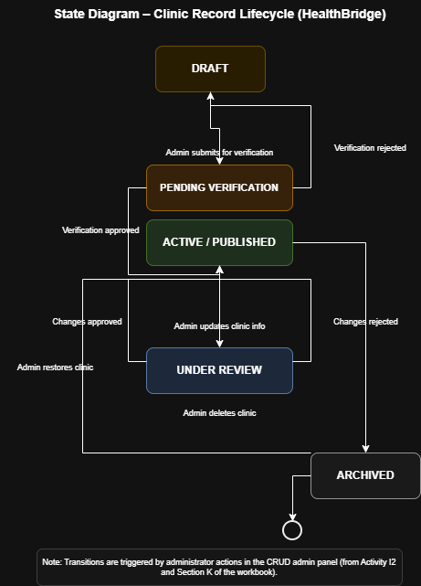
Transitions are triggered by administrator actions in the CRUD admin panel.
SECTION K: DESIGN PATTERNS IN PRACTICE

Activity K1: Design Challenge in HealthBridge
Challenge: Multiple system components (Search Engine, Admin Panel, Notification Service) all need to react when clinic data changes. If each component checks the database independently for changes, this creates tight coupling and inefficiency — a change to one component could break others.

Activity K2: Applied Design Pattern
Pattern: Observer Pattern
Solution: The Clinic Model acts as the Subject (Observable). When an administrator updates or adds a clinic record, the Clinic Model notifies all registered Observers automatically:
• Redis Cache Observer — invalidates the cached search results for that region
• Notification Observer — sends an alert email/SMS to subscribed administrators
• Audit Log Observer — writes a change record to the activity log
This decouples the components: the Clinic Model does not need to know what observers exist, and new observers (e.g., a analytics tracker) can be added without modifying existing code.
SECTION L: IMPLEMENTATION PLANNING

Activity L1: Build vs Buy Decision
Decision: Hybrid , we build the core application but reuse existing libraries and services.
Reason: Building everything from scratch would be time-prohibitive for a student project. Reusing proven open-source libraries (React, Express, Sequelize) reduces development time, improves reliability, and lets the team focus on HealthBridge-specific business logic. External services like Google Maps API are used for mapping rather than building a custom mapping engine.

Activity L2: Tools & Technologies
- Programming Language: JavaScript (Node.js for backend, React.js for frontend)
- IDE: Visual Studio Code
- Database: PostgreSQL (primary) + Redis (caching)
- Frameworks/Libraries: Express.js (REST API), Sequelize ORM, React.js, Tailwind CSS, JWT (auth), bcrypt (password hashing), Axios (HTTP client)

Activity L3: Task Allocation
Member 1 — Tumukunde Isaac (2024/BCS/162/PS), Project Lead + Backend API (Express Controllers, routing)
Member 2 — Aryamanya Lucky (2024/BCS/045/PS), Database Design (PostgreSQL schema, Sequelize models, migrations)
Member 3 — Nambatya Bladina Doreen (2024/BCS/128/PS), Frontend Development (React components, search UI, clinic cards)
Member 4 — Nanjuki Daphine (2024/BCS/129/PS), Frontend Development (Admin panel UI, maps integration)
Member 5 — Kusingura Jachin (2024/BCS/091/PS), Security & Authentication (JWT, bcrypt, HTTPS config, input validation)
Member 6 — Arinda Leticia (2024/BCS/043/PS), Testing & Documentation (unit tests, API docs, deployment scripts)

SECTION M: SOFTWARE REUSE

Activity M1: Reusable Components
- React.js — pre-built UI component library for building the frontend interface
- Express.js — reusable HTTP routing framework for Node.js
- Sequelize ORM — reusable database abstraction layer; avoids writing raw SQL for CRUD operations
- Bcrypt.js — reusable password hashing library; no need to implement cryptography from scratch
- Google Maps JavaScript API — reusable mapping service for displaying clinic locations

Activity M2: Evaluate Reuse
Benefits:
• Saves significant development time — proven libraries handle complex tasks (auth, mapping, ORM)
• Improves reliability — widely used libraries are battle-tested and well-documented
• Reduces security risks — libraries like bcrypt implement cryptography correctly
Challenges:
• Dependency management — updates to libraries can introduce breaking changes
• Learning curve — team members must understand library APIs before using them
• Licensing — all open-source libraries used must have permissive licenses (MIT, Apache 2.0) compatible with the project
──────────────────────────────────────────────────────────────────────

SECTION N: CONFIGURATION MANAGEMENT

Activity N1: Version Control Tool
Tool: Git with GitHub as the remote repository hosting service.

Activity N2: Versioning Strategy
Branching Strategy Git Flow:
• main branch — production-ready code only; protected from direct pushes
• develop branch — integration branch where all feature branches are merged
• feature/[name] branches — each team member works on their feature in isolation
(e.g., feature/clinic-search, feature/admin-panel, feature/auth)
• hotfix/ branches — for urgent production bug fixes
Commit Convention: Descriptive messages in format: [type]: [description]
(for examplefeat: add clinic search endpoint, fix: resolve Redis cache invalidation bug)
Pull Requests: All merges to develop require at least one peer code review before approval.

SECTION O: DEPLOYMENT & ENVIRONMENT

Activity O1: Development vs Execution Environment
Development Platform:
• OS: Windows 10/11 or Ubuntu Linux on team laptops
• Tools: VS Code, Node.js v18 LTS, PostgreSQL 15 (local), Redis (local via Docker)
• Version Control: Git + GitHub
• Local Testing: Postman (API testing), Jest (unit tests)
Execution (Production) Platform
• Cloud: Google Cloud Platform
• Backend: Google Cloud Run (containerised Node.js app, auto-scales to zero)
• Frontend: Firebase Hosting (global CDN, HTTPS by default)
• Database: Google Cloud SQL (managed PostgreSQL instance)
• Cache: Google Cloud Memorystore (managed Redis)
• Domain: Custom domain with SSL certificate

Activity O2: Deployment Diagram Description
Components and their physical locations:
User's Browser ──HTTPS──► Firebase CDN (React frontend)
│
REST API calls
│
Google Cloud Run
(Node.js/Express App)
│ │
Cloud SQL Cloud Memorystore
(PostgreSQL) (Redis)
All components communicate over private VPC network; only Cloud Run and Firebase are publicly accessible.

SECTION P: OPEN SOURCE CONSIDERATIONS

Activity P1: Use of Open Source
Yes, HealthBridge relies extensively on open-source tools and libraries.
- React.js (MIT License) — frontend framework
- Node.js (MIT License) — backend JavaScript runtime
- Express.js (MIT License) — web application framework
- PostgreSQL (PostgreSQL License) — relational database
- Redis (BSD 3-Clause) — in-memory cache
- Sequelize (MIT License) — ORM for Node.js
- Bcrypt.js (MIT License) — password hashing

Activity P2: Licensing Awareness
Key licensing considerations for HealthBridge:
1. All libraries used carry permissive licenses (MIT, BSD, Apache 2.0), which allow use in both commercial and non-commercial projects without requiring the project itself to be open-sourced.
2. GPL-licensed software must be avoided unless HealthBridge itself is released as open source, as GPL requires derivative works to also be GPL.
3. Attribution: MIT and BSD licenses require that the original copyright notices are preserved in the distributed software.
4. Google Maps API: This is a proprietary service with usage quotas and billing beyond free tier limits. The team must monitor API call volumes and consider an open-source alternative (e.g., Leaflet + OpenStreetMap) if costs become prohibitive.

FINAL PROJECT PROGRESS CHECKLIST
System context defined; HealthBridge connects patients, admins, Maps API, and cloud infrastructure
Use cases developed; Clinic Search and Admin Data Update
Objects identified; User, Clinic, Service, Admin, SearchQuery
UML diagrams created; Class Diagram, Sequence Diagram, State Diagram
Design patterns applied; MVC (architectural), Observer (component communication)
Implementation plan ready; tools, languages, and frameworks selected
Tools selected; React, Node.js, PostgreSQL, Redis, Git
Version control defined; Git Flow with GitHub, pull request reviews
Deployment planned ; Google Cloud Platform (Cloud Run, Cloud SQL, Firebase Hosting)

